**Loading to SAL Layer Data**

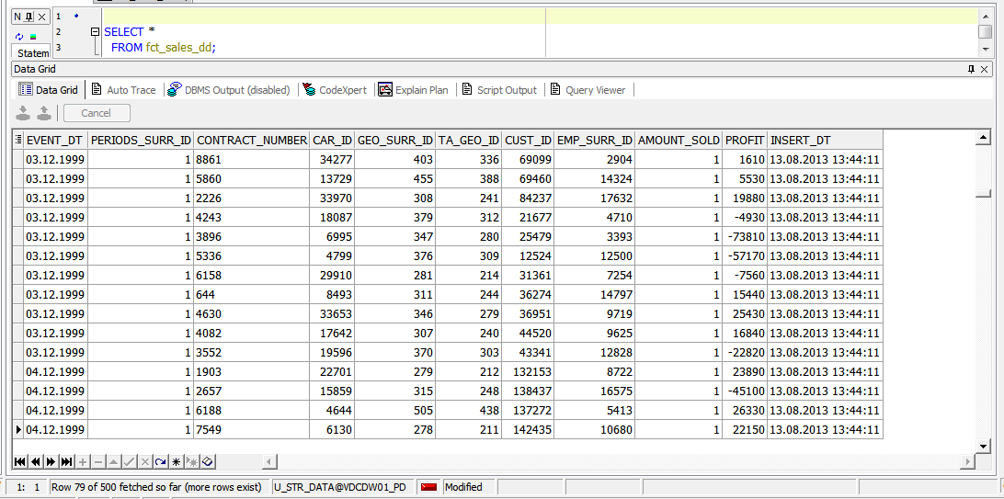

**Prepare Report Layout**

SELECT DECODE ( GROUPING_ID ( cr.brand

, geo.country_desc )

, 1, ''

, 3, 'Grant total'

, geo.country_desc )

ascustomer_country

, DECODE ( GROUPING_ID ( cr.brand

, geo.country_desc )

, 1, 'Total for ' || cr.brand

, cr.brand )

AS brand

, TO_CHAR ( SUM ( sal.profit )

, '$999,999,999,999' )

AS profit

, SUM ( amount_sold ) AS quantity

FROM fct_sales_dd sal

JOIN dim_cars cr

ON ( sal.car_id = cr.car_id )

JOIN dim_geo_locations_scd geo

ON ( sal.geo_surr_id = geo.geo_surr_id )

WHERE TRUNC ( sal.event_dt

, 'Month' ) = TO_DATE ( '7/1/2013'

, 'MM/DD/YYYY' )

AND sal.profit > 0

GROUP BY ROLLUP ( cr.brand, geo.country_desc );

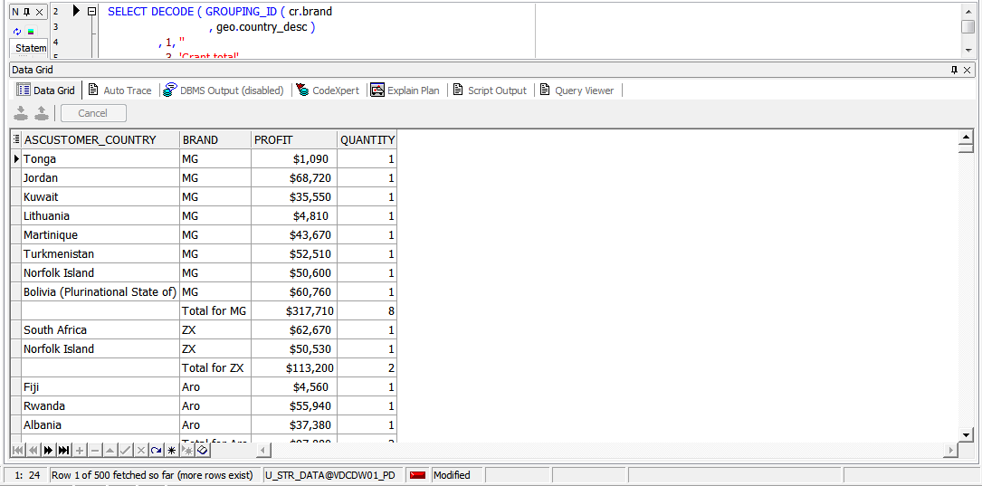

**Compare Report Layout Performance**

|  |  |  |  |
| --- | --- | --- | --- |
| № | Source Type | Explain Plan - Statistics | Time, Sec. |
| 1 | Advancing Grouping |  | 0.38 |
| 2 | Model Clause |  | 1 |
| 3 | Star Schema |  | 0.29 |